Under 11 Boys Singles
Winner | Aled Williams
Runner up | Mason Gullick
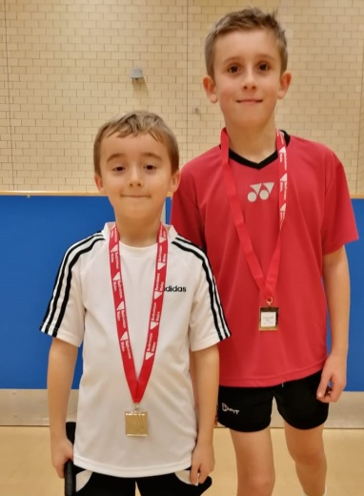
Under 13 Girls singles
Winner | Bhavana Balu
Runner up | Ishasyria Mekala
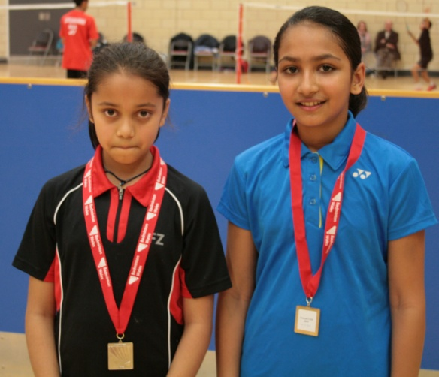
Under 13 boys Singles
Winner | Zachary Morris
Runner up | William Higgs
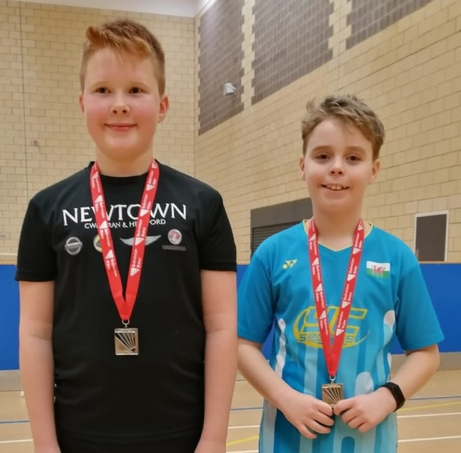

Under 13 Boys Doubles
Winners | Aled Williams & Zachary Morris
Runners up | William Higgs & Harri Owen
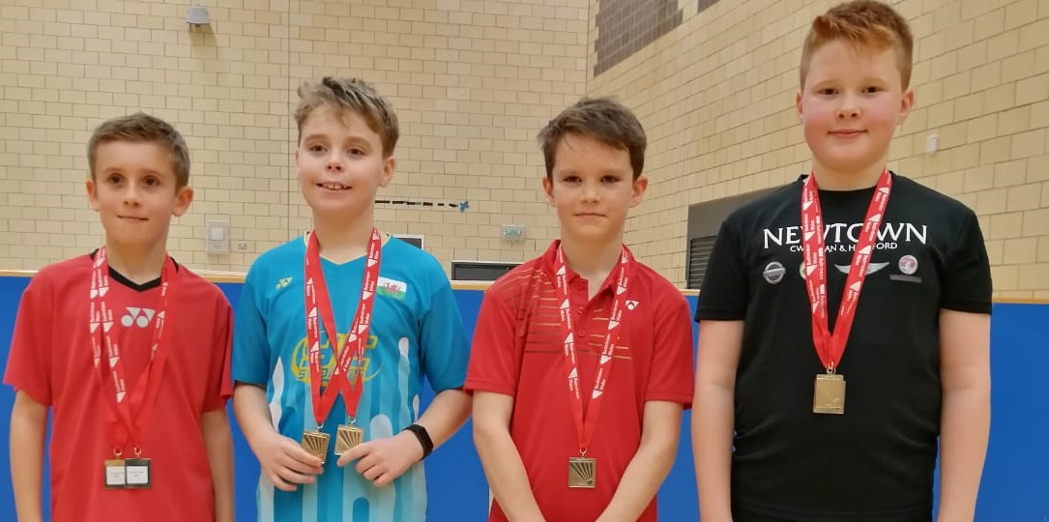
Under 13 Mixed Doubles
Winners | Hannah Ahmed & Harri Owen
Runners up | Nandna Suresh & Mason
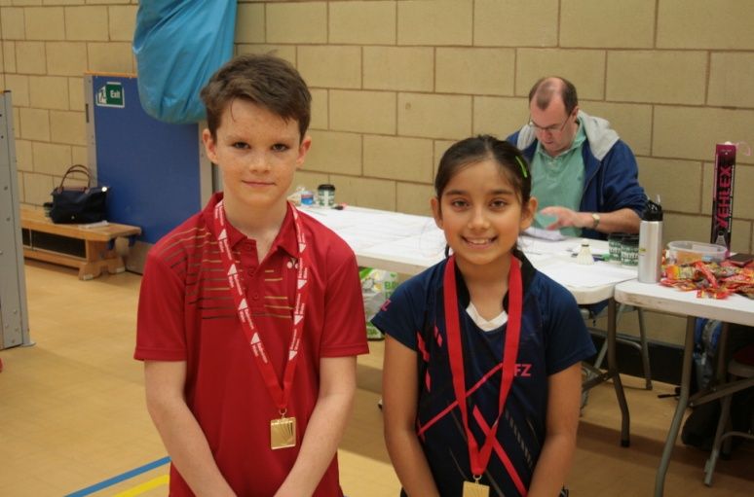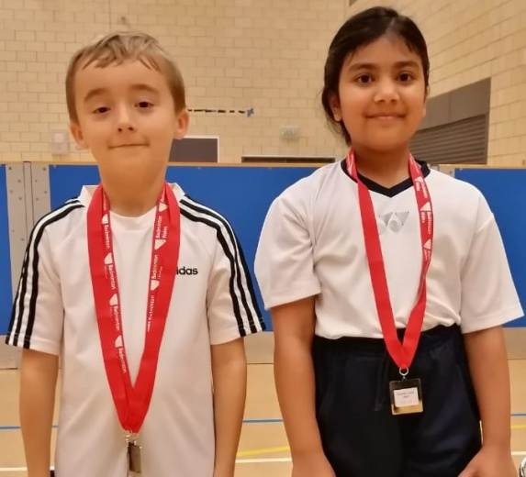
Under 15 Girls Singles
Winner | Bhavana Balu
Runner up | Anest Lewis Fells
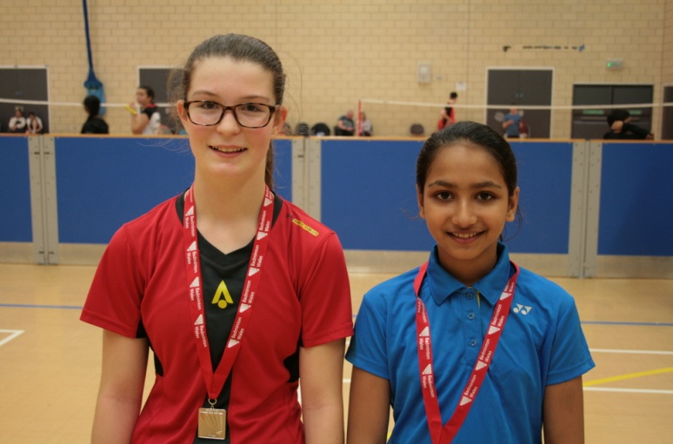

Under 15 Boys Singles
Winner | Amay Patil
Runner up | Llwyd Crump
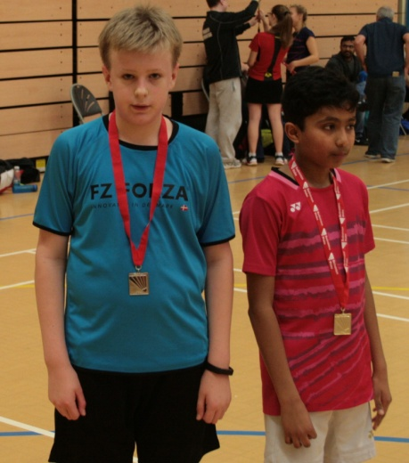
Under 15 Boys Doubles
Winners | Amay Patil & Eshaan Patil
Runners up | Faaris Ahmed & Llwyd Crump
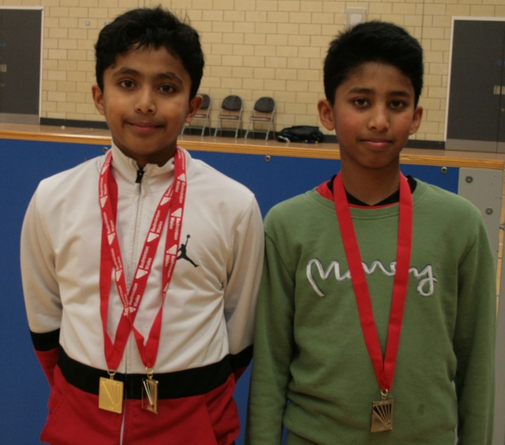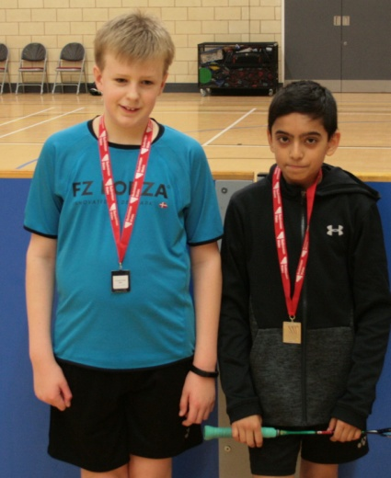
Under 15 Mixed Doubles
Winners | Anest lewis Fells & Llwyd Crump
Runners up | Neve Thomas & Joshua Humphreys
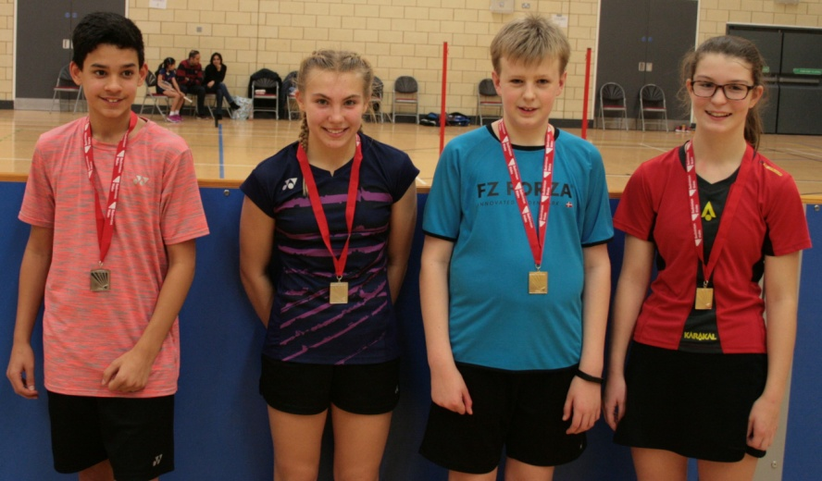

Under 15 Girls doubles
Winners | Nishita Gopi & Sot-Sai Thomas
Runners up | Anest Lewis Fells & Neve Thomas

Under 17 Girls Singles
Winner | Chloe Barton
Runner up | Maisie Kite
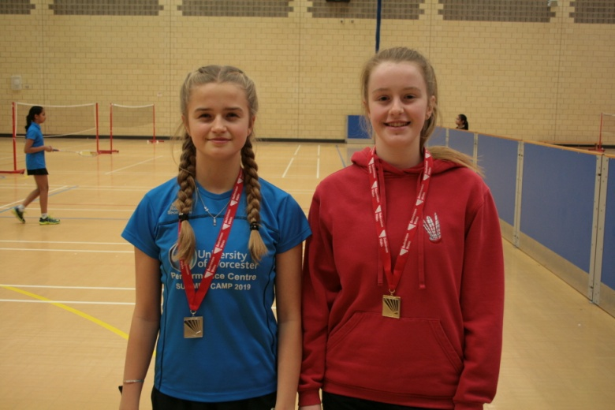
Under 17 Boys Singles
Winner | Amay Patil
Runner up | Eshaan Patil
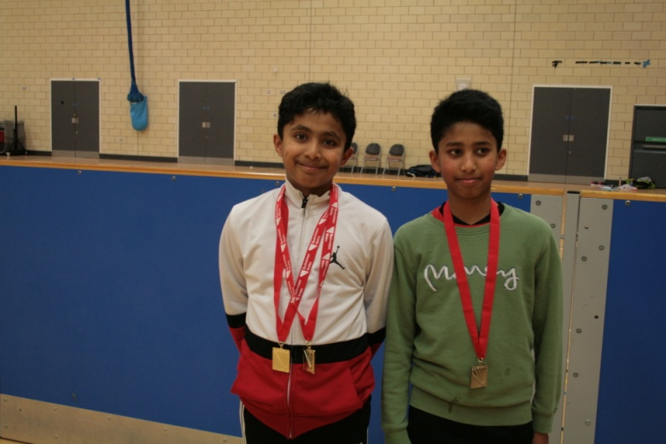

Under 17 Mixed doubles
Winners | Nabil Taufiqurrahman & Maisie Kite
Runners up | Nye Bennett & Chloe Barton
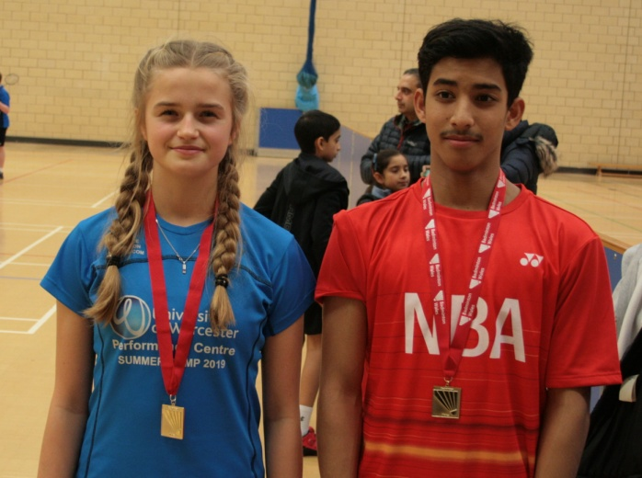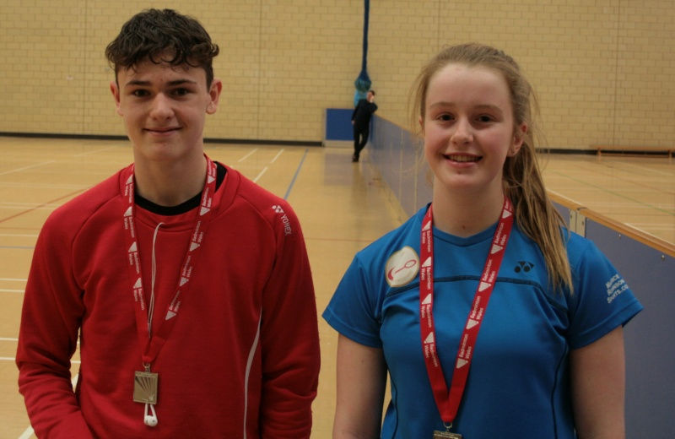
Under 19 Boys Singles
Winner | Matthew Logan
Runner up | Nabil Taufiqurrahman
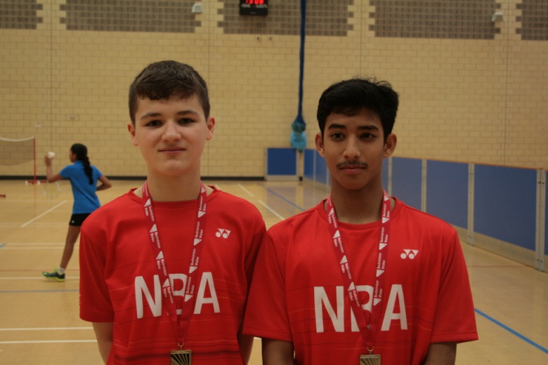
Under 19 Boys Doubles
Winners | Jude Wiseman & Andrew Salvadore
Runners up | Tom Barnes & Nabil Taufiqurrahman
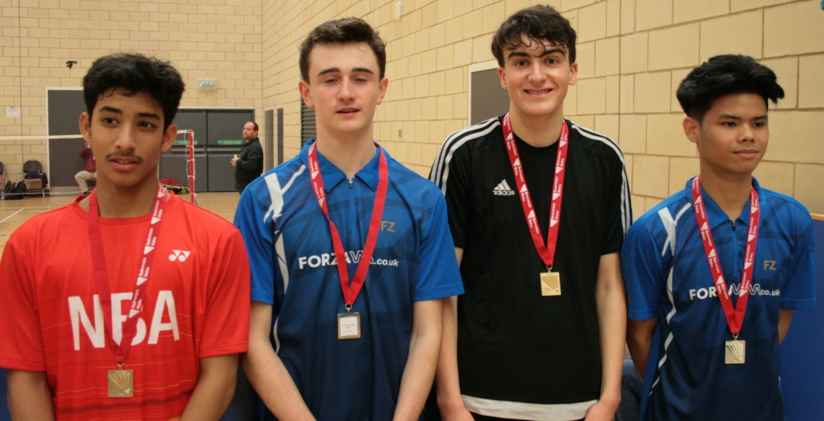

Under 19 Mixed Doubles
Winners | Fern Williams & Andrew Salvador
Runners up | Maisie Kite & Tom Barnes
