Schools Pack 2021-22

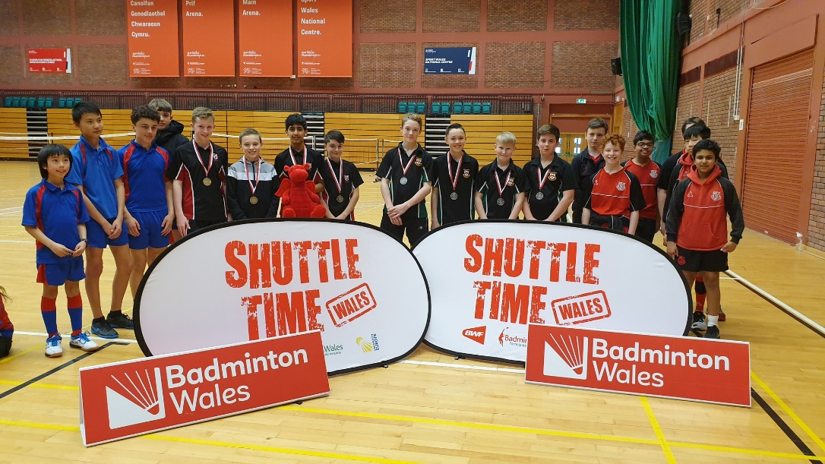

Badminton Wales Shuttletime Competition

The Shuttle Time Schools Competition is aimed at grassroot players and open to all secondary schools in Wales. Students who are already within the Badminton Wales Performance Pathway are not able to take part – for these students we recommend our Top Schools event.

Local Authorities are responsible for organising their own local event, where the Boys and Girls winners from years 7&8 and 9&10 go forwards to compete in the regional finals, usually held in March. The entry form and regulations can be found on our website here: https://www.badminton.wales/shuttle-time

The entry fee for the South and North finals is £15 per team, payable in advance.

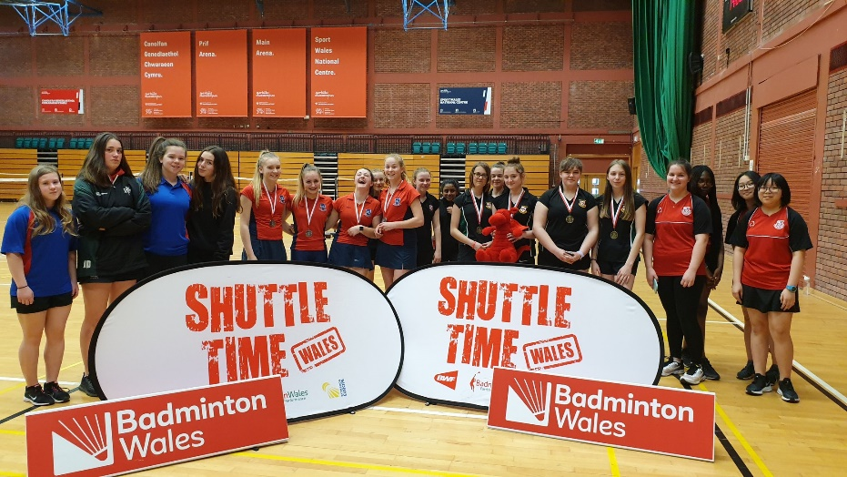
Badminton Wales Top Schools Competition

The Top Schools competition is a higher level competition, inclusive of the Badminton Wales performance players.
The entry fee is £15 per team, payable in advance.

Each year there are 2 regional events, one in North Wales and one in South Wales, in October with the top 3 Boys and Girls teams progressing through to compete in the National Finals (usually held in Mid Wales in February.)
The entry form and regulations can be found here: https://www.badminton.wales/development

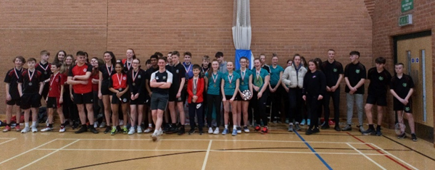

BWF Shuttletime Youth Leadership Award

The BWF Shuttle Time Youth Leadership Award has been designed to allow students the opportunity gain experience in sports leadership and badminton through Shuttle Time. The award aims to provide students with the knowledge and support required to deliver fun, safe and enjoyable badminton lessons to groups of school pupils.

If Schools and Colleges provide at least 16 students and badminton courts, Badminton Wales will provide a tutor to deliver the Youth Leadership Award in your school.

The Shuttle Time Youth Leadership Award covers both badminton and leadership tasks and is delivered in a modular format. The course is broken down into 5 core modules of the Key attributes of a Young Leader, Planning a Sports Session, Communication Skills, Managing a group and Fair Play, Officiating and Volunteering in Sport which are all linked to the Shuttle Time Programme. The course will be delivered over a full day.

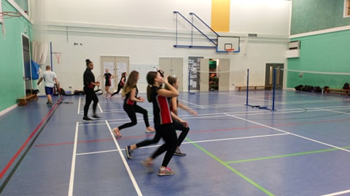

BWF Shuttle Teachers Award

In 2012 BWF launched Shuttle Time to the world. A schools badminton programme supporting the principle that children should lead a healthy and active life, both in and out of school. BWF’s goal is to make badminton one of the world’s most popular and accessible school sports.

Shuttle Time offers school teachers access to free resources, training and equipment, which support the teaching of enjoyable, safe and inclusive badminton activities to children aged 5-15 years old. Shuttle Time lessons are designed to provide children with a positive image of badminton through many opportunities to have fun, engage with others and experience success.

Badminton Wales are offering all Primary and Secondary schools in Wales the opportunity to be Shuttle Time trained by undergoing a course at no cost to your school, delivered by Badminton Wales. The Shuttle Time program is an online lead program with over 90 video clips of all the exercises and over 20 weeks of session plans. The course will guide teachers and provide them with the knowledge to deliver the Shuttle Time sessions.

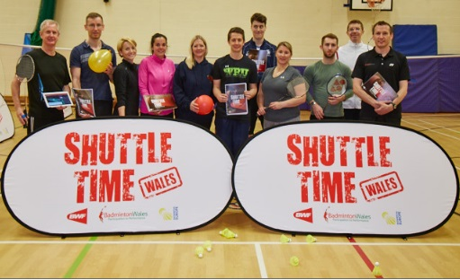

Shuttle Time App

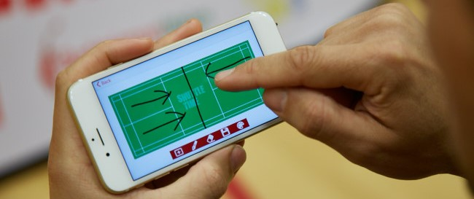

Shuttle Time App – Free on GooglePlay and AppStore
– Available in 20 Languages
– 22 Lesson Plans
– 92 Activities
– Competition Table
– Scoreboard
– Draw Feature

