Aspire Programme
Introduction
Badminton Wales is passionate about the future generations of badminton leaders in Wales. As a result, a new National Youth Development Scheme has been established.
What is the Aspire Programme?
- An inclusive, two-year National Youth Development Scheme to provide the next generation of badminton leaders with knowledge, skills and experiences to effectively play their part in the future of Welsh badminton, from grassroots to high performance.
Who is it for and How to Apply?
- Anyone between the ages of 16 and 20 who is a current member of Badminton Wales.
- The programme will accept up to 8 applicants in Autum/Winter 2023 for commencement in Jan. 2024.
- Applications can be made via an application form, to be submitted by November 13th at 09.00h.
- Short, informal interviews will take place on the evenings of w/c 23rd November, with decisions and personal feedback delivered shortly after.
- Applications should be submitted via email to donal.ohalloran@badminton.wales.

Who Are You?
- What are our ideal person criteria?
Must be aged between 16-20 in Jan 1st 2024
  - Badminton Wales is looking to inspire the next generation of badminton enthusiast. The ideal candidate will have a keen desire to develop themselves in a variety of areas of badminton administration and coaching.
  - Individuals must be committed to the Programme and prioritise Aspire as part of their own personal development.
  - Candidates must be capable of attending Face to Face sessions nationwide.
  - Candidates must be capable of travelling and staying away from home independently (within BW Safeguarding policies and procedures).
  - Must be willing to actively engage with coaching opportunities linked to National Squads ie attend and deliver.
  - Attend and deliver sessions linked to the Technical Officials Development.
  - Must be organised.
  - Must have a keen interest in badminton
  - Must have good people skills and be willing to develop them further.
  - Must have good communication skills.
  - Must have excellent Time Management skills.

Our Commitment to You:
Over the 24-month programme, full engagement with the Aspire programme will lead to achievement of the following:
- Badminton Wales Aspire Youth Leadership Programme award certificate.
- Volunteering experience within BW and the community, which can be completed as part of the Welsh Baccalaureate Qualification, Duke of Edinburgh Award volunteering section, and/or the Youth Sport Trust Young Ambassador programme.
- Emergency first aid at work qualification (valid for 3 years), Safeguarding and Protecting Children qualification (valid for 3 years*), and Badminton Wales DBS check (valid for 3 years *).
- Membership of Badminton Wales Youth Council.
  - Potential for additional Chair or Secretary role to be undertaken for set term.
  - Experience engaging and writing formal meeting agendas and minutes, as undertaken by club committees.
  - Opportunity to present and interact with BW Board of Directors.
  - Involvement in development of written reports and presentations to Board.
- Coach development opportunities:
  - Mentorship from national coaches.
  - Practical experience planning and delivering badminton sessions (e.g., in community, regional academies, National Squads and/or Talent ID events)
- Disability awareness training (valid for 3 years).
- Experience planning and running events:
  - Major international events (e.g., WINT).
  - Community events.
  - Insight into event logistics, finance, organisation etc.
- Media management training (including social media).
- Technical officials’ line judging course.
  - Opportunities to volunteer courtside at all BW events.
  - Opportunities to engage with umpiring qualifications.
- Opportunity to complete basic UKSCA strength and conditioning training.
- Submission for BWF Level 1 coaching course, when appropriate.
Tier 1 – CORE Components | Timeline
- First aid  - Safeguarding (*age appropriate)  - DBS(*age appropriate)  - Youth Council | Completed in First 6 Months  Funded by £150 enrolment fee
Tier 2 – CORE Components
- Coach Education & Development  - Disability & Inclusivity Training  - Volunteering  - Event Planning and Management | Completed Continually Over 24 Months Directly Funded/Facilitated by BW
Tier 3 – OPPORTUNITY Components
- S&C  - Technical officials  - Media Management  - Mental Health Awareness Training  - Anti-Doping Awareness & Fair Play  - Match Analysis | Opportunities that may arise along the way, possibly with additional cost?  No requirement to complete these to achieve Aspire qualification?

Your Commitment to Us:
- An enthusiasm for badminton, and a keen interest in personal development.
- In person attendance at 3 weekends (Saturday & Sunday) over the 24-month period, which will likely be across Wales. There will be no direct cost for these weekends, but Badminton Wales will not be able to subsidise travel and/or accommodation.
- Online attendance for 1 x 3-hour workshop session per month with BW development.
- Engagement with, and timely completion of, monthly or bi-monthly tasks.
- Online attendance for BW Youth Council meetings (often held once every 6-8 weeks).
- In person attendance at, at least one Welsh International Open Tournament, held over four days in Cardiff at end of November/start of December.
- 40 hours of documented volunteering within BW or the community, over the course of the programme.
- A nominal fee of £150 paid upfront upon enrolment, to cover basic administrative costs associated with the programme.
- Affiliation to Badminton Wales (if not currently affiliated, this can be arranged for free upon enrolment fee payment).
Transferrable skills for CV & Personal Statement
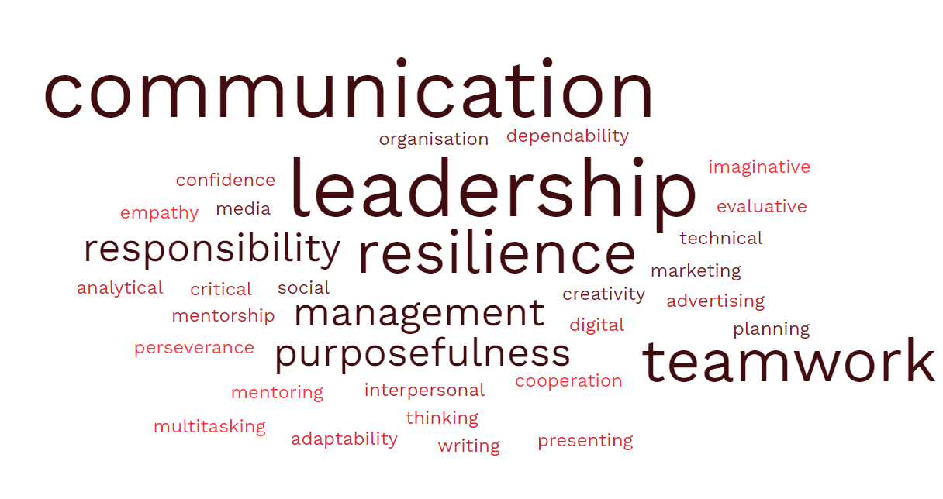Aspire Award
The Aspire Award will be awarded to any individual who completes all CORE components of the Aspire programme. Individuals will be required to keep a logbook of achievements, but no formal assessment will be conducted.
Beyond Aspire
We hope the Aspire programme will equip individuals with a range of skills to continue their involvement in badminton into the future, whether that be in voluntary or full-time positions. Any individual who has the desire to complete the BWFL1 coaching course will be considered for submission to this, at a subsidised rate, towards the end of the Aspire programme.

Badminton Wales Youth Council
All members of Aspire will become active members of the BW Youth Council, who’s overarching mission is:
“To provide a voice for the young badminton community in Wales, and to work with Badminton Wales in identifying, proposing, and implementing best practices for the benefit of this community and the wider Badminton Wales community, at all levels of the badminton pyramid.”
The Youth Council reports directly to the CEO and Board of Directors periodically, commonly via a short formal report and/or verbal presentation. Operating within the BW Strategy, the Board and BW staff consult the Youth Council on key issues involving the youth population. This may include, but is not limited to, simplification of complex policy for young people, volunteering opportunities, coaching pathways for young people and the Aspire programme.
Youth Council meetings are generally held virtually, every 6-8 weeks, led by a Chairperson and secretary.
- The Chairperson’s role is to lead Youth Council meetings; lead communication with BW staff and Board Liaison Officer; develop report and give presentation to Board.
- The role of the Secretary (or Secretaries) is to assist the Chair with all their roles and write formal agendas and minutes for Youth Council meetings.

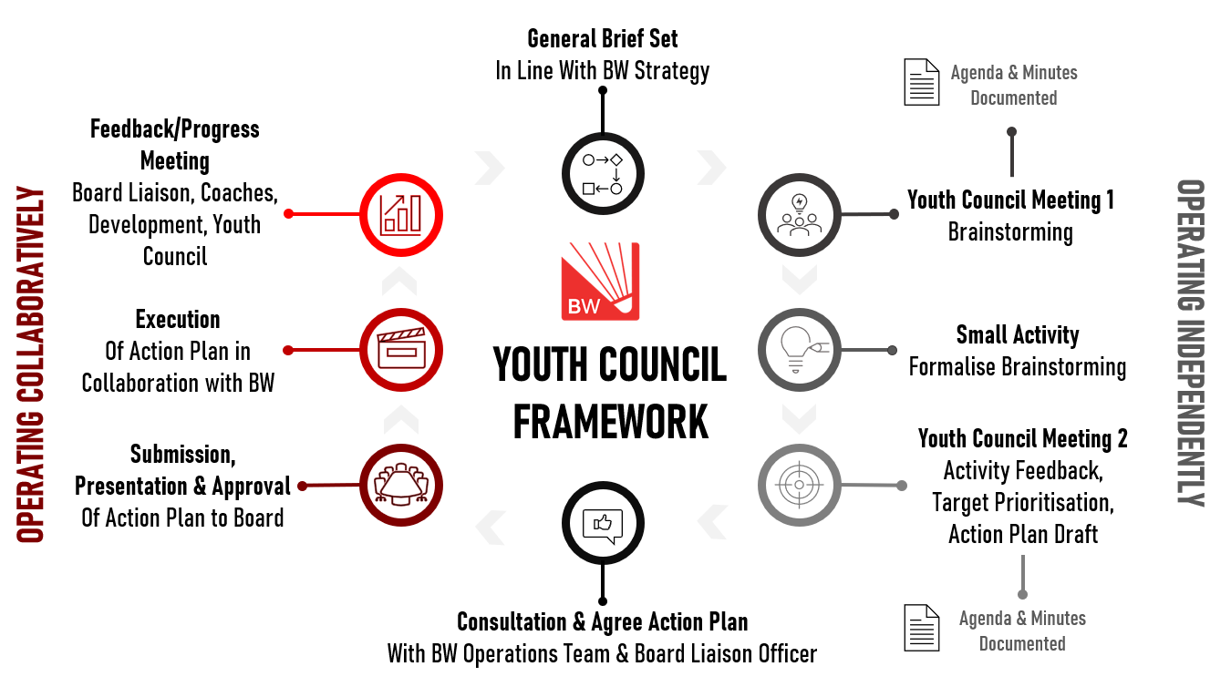
The framework for Youth Council operations was approved by the BW Board in July 2023.

Aspire BW Aims and objectives
- To upskill young badminton leaders with badminton-specific and transferrable skills that facilitate and encourage them to continually engage in badminton activities, both locally and nationally in the future.
  - To upskill leaders with skills and attributes for involvement in club committees.
  - To upskill leaders with skills and attributes to organise and run events.
  - To upskill leaders in technical officiating.
- To provide young badminton leaders with coaching mentorship, knowledge, and experience.
  - To provide mentorship through online and in-person workshops with national coaches.
  - To provide basic certification including first aid, safeguarding and DBS to facilitate coaching.
  - To facilitate coaching experience within national junior squad and community settings.
  - To facilitate individuals working towards being submitted for BWF Level 1 coaching qualification at the end of the programme.
- To provide a functional and productive Youth Council that directly supports the BW strategy.
  - To form a Youth Council consisting of Aspire programme members.
  - To work with BW Board, Board Liaison Officer and BW staff to support Youth Council to operate within the approved Youth Council framework.
  - To use Youth Council to provide input into topical BW matters.

